**Git HOL – 3**

**Questions & Answers –**

1. **Explain branching and merging**

**Ans –**

* A branch is a parallel version of your project where you can work independently without affecting the main codebase.
* Merging means bringing changes from one branch into another (usually into main).

1. **Explain about creating a branch request in GitLab**

**Ans –** You can create a branch either **via GitLab UI** or **Git CLI**:

**Using GitLab Web UI**

1. Go to your project (e.g., GitDemo).
2. Click on **Repository → Branches**.
3. Click **"New branch"**.
4. Name your branch (e.g., feature-xyz), and choose source (usually main).
5. Click **"Create branch"**.

You now have a new branch in GitLab where you can push your changes.

**Using GitLab CLI**

git checkout -b feature-xyz

# make your changes

git add .

git commit -m "Work on feature xyz"

git push -u origin feature-xyz

1. **Explain about creating a merge request in GitLab**

**Ans –** A **Merge Request** in GitLab is how you request to **merge one branch into another** — like feature-xyz into main.

**Steps to Create a Merge Request:**

1. After pushing your feature branch to GitLab:
2. Go to your project repository.
3. GitLab will often **auto-suggest** creating a merge request. Click on **"Create merge request"**.  
   OR go to:
   * **Merge Requests → New merge request**
4. Select:
   * **Source branch**: your feature branch (e.g., feature-xyz)
   * **Target branch**: usually main
5. Fill in:
   * Title
   * Description (what was changed, why)
   * Assignees, reviewers, etc. (if in a team)
6. Click **"Create merge request"**

GitLab will show diffs, run CI/CD if configured, and allow review/comments.

**Branching –**

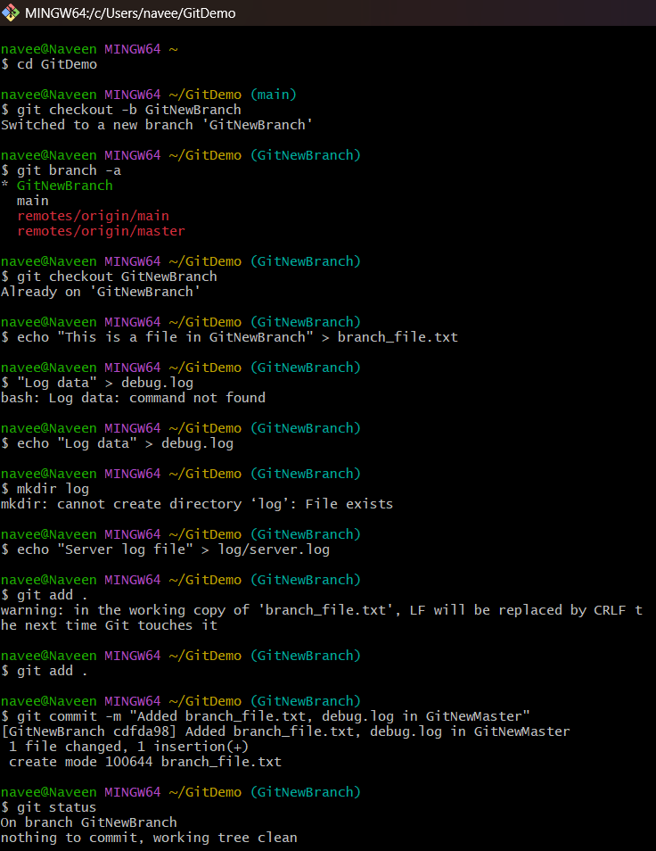

**Merging –**

